**Leonides Guerra**

**Pandas Challenge**

**Heroes of PyMoli Analysis**

The results of the Heroes of PuMoli analysis for game purchases are as follows:

* There are a total player count of **576 Players**

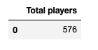

* There are **179 items** in the store
* The average price for this items is **$3.05**
* There were **780** purchases
* With a total revenue of **$2,379.77**

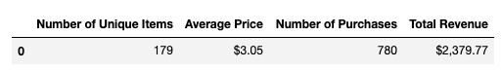

**Gender Demographics**

* 87% of players are male
* 14% are female
* 1.91% are Non-Disclosed

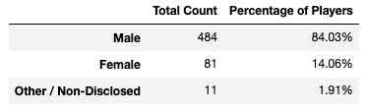

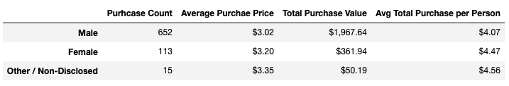

**Age Demographics**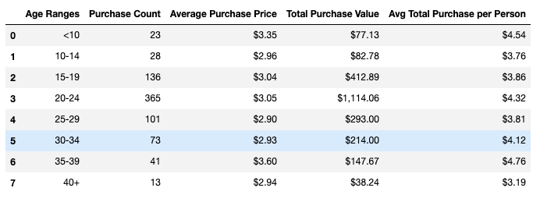

**Top Spenders**

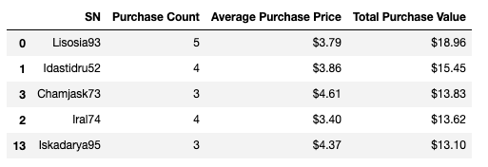

**Most Profitable Items**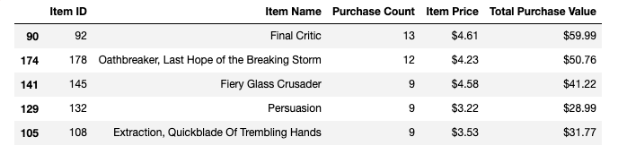

**Most Profitable Items**